Exercise 1: Create a Stored Procedure
create database employeesdb;
use employeesdb;
create table departments
(
departmentid int primary key,
departmentname varchar(100)
);
create table employees
(
employeeid int identity(1,1) primary key,
firstname varchar(50),
lastname varchar(50),
departmentid int,
salary decimal(10,2),
joindate date,
foreign key (departmentid) references departments(departmentid)
);

insert into departments(departmentid,departmentname) values
(1, 'HR'),
(2, 'Finance'),
(3, 'IT'),
(4, 'Marketing');

insert into employees (firstname,lastname,departmentid,salary,joindate) values
('John', 'Doe', 1, 5000.00, '2020-01-15'),
('Jane', 'Smith', 2, 6000.00, '2019-03-22'),
('Michael', 'Johnson', 3, 7000.00, '2018-07-30'),
('Emily', 'Davis', 4, 5500.00, '2021-11-05');
create procedure sp_GetEmployeesByDepartment
@departmentid int
as
begin
select
employeeid,
firstname,
lastname,
departmentid,
salary,
joindate
from employees
where departmentid=@departmentid;
end;
exec sp_GetEmployeesByDepartment @departmentid = 3;
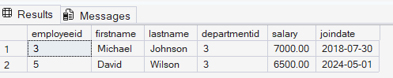

create procedure sp_InsertEmployee
@firstname varchar(50),
@lastname varchar(50),
@departmentid int,
@salary decimal(10,2),
@joindate date
as
begin
insert into employees
(firstname, lastname, departmentid, salary, joindate)
values
(@firstname, @lastname, @departmentid, @salary, @joindate);
end;
exec sp_InsertEmployee
@firstname = 'David',
@lastname = 'Wilson',
@departmentid = 3,
@salary = 6500.00,
@joindate = '2024-05-01';
select * from employees;
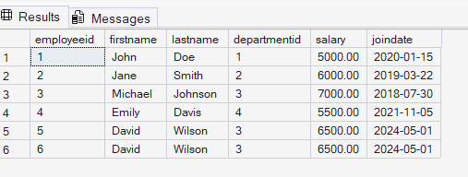

select name from sys.procedures;

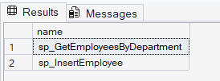
Exercise 5: Return Data from a Stored Procedure

create procedure sp_GetEmployeeCountByDepartment
@departmentid int
as
begin
select count(*) as totalemployees
from employees
where departmentid = @departmentid;
end;

exec sp_GetEmployeeCountByDepartment @departmentid = 3;
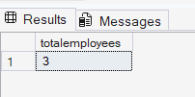

select name
from sys.procedures
where name = 'sp_GetEmployeeCountByDepartment';
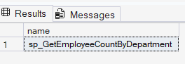

Exercise 4: Execute a Stored Procedure
create procedure sp_GetEmployeesByDepartment
@departmentid int
as
begin
select
employeeid,
firstname,
lastname,
departmentid,
salary,
joindate
from employees
where departmentid = @departmentid;
end;

exec sp_GetEmployeesByDepartment @departmentid = 3;
